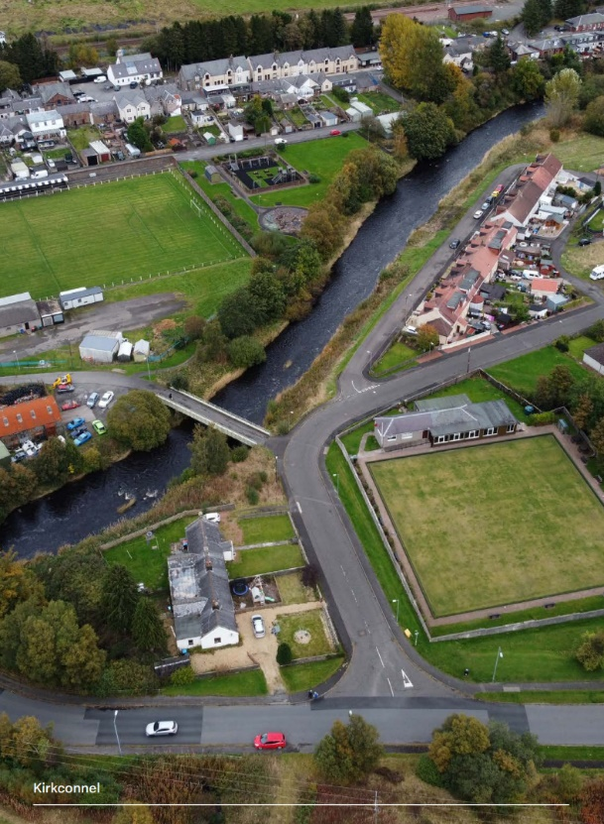

Introduction
Kirkconnel and Kelloholm form a rural community in the Mid and Upper Nithsdale Ward of Dumfries and Galloway with a population of approximately 2000 people. From the census data we note the age groups as the following 0 – 17 years: 437, 18 – 64 years: 1,129, 65+: 440.

The communities grew considerably through the 20th century to serve the many coal mines in the area, all of which have now closed. Now, Kirkconnel and Kelloholm are amongst the most deprived communities in Dumfries and Galloway, with their citizens experiencing some of the poorest outcomes across several indicators.

This Locality Plan aims to address the needs of these communities, to address the inequalities that exist and to improve the outcomes for citizens in future.

By working through the Community Planning Partnership, partners will work closer and more creatively in these communities to bring additionality and added value to services. By involving communities throughout the process citizens should recognise actions taking place to bring about the necessary change.

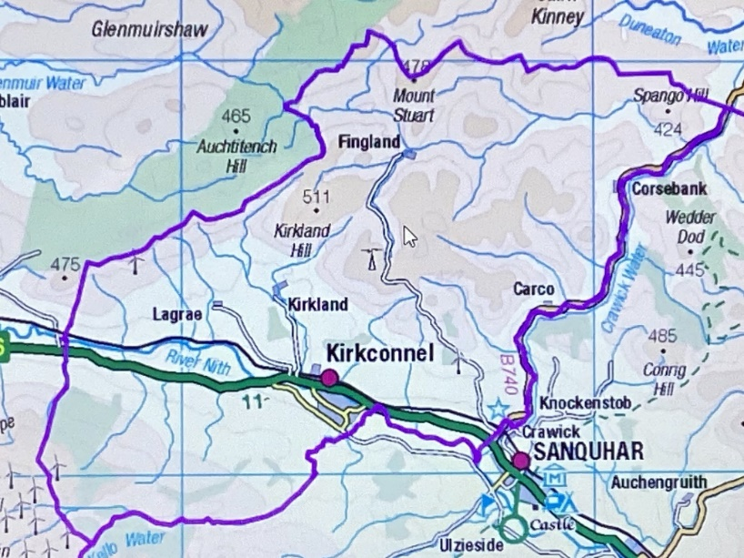

Strategic and Operational Community Planning Context
Community Planning brings together key public, private and third sector agencies in our area, working in partnership with each other and with local communities to plan and deliver better services for the people of Dumfries and Galloway.

There are five public bodies that have a legal requirement to facilitate community planning and ensure the Partnership carries out its functions efficiently and effectively.
- Dumfries and Galloway Council
- NHS Dumfries and Galloway Board
- Police Scotland
- Scottish Fire and Rescue Service
- South of Scotland Enterprise

Third Sector Dumfries and Galloway, as the local Third Sector Interface is involved at all levels of Community Planning in Dumfries and Galloway and therefore the interface and third sector organisations such will be involved in the delivery of this Plan. The Dumfries and Galloway Poverty and Inequalities Partnership is also currently delivering a wide range of projects throughout our Region, including the areas covered by this Plan, which have been specifically designed to target poverty and inequalities in all its forms.

Community organisations relative to this Plan have been involved in its development and include: Kirkconnel and Kelloholm Community Council, and Kirkconnel and Kelloholm Development Trust. These organisations will be actively involved throughout its implementation and ongoing monitoring.

Community Participation and Engagement
During the development of this Locality Plan, reflection was made of the various action plans, community plans, research and appraisals which have taken place within the communities over the past ten years. This has included the significant consultation activity undertaken as part of the Borderlands Place Plan which focuses specifically on Kirkconnel. To ensure the needs and aspirations of the community of Kelloholm are fully captured, further engagement has been undertaken with the Community Council, local Development Trust, other local groups and the Town Team.

The Nithsdale Locality Hub, where operational officers from Community Planning Partners come together at a local level have been engaged in the development of the Plan with appropriate Officers being engaged where specialist knowledge or insight has been required.

Vision
The citizens and communities of Kirkconnel and Kelloholm will thrive as Community Planning Partners work together to tackle inequality and socio-economic disadvantage.

Needs Assessment
Community plans covering Kirkconnel and Kelloholm developed over the last ten years have been reviewed. These include:
- Kirkconnel Parish Place Plan, 2023-2033
- Kirkconnel Multi-Modal Transport Appraisal, 2022
- Kelloholm Skills and Innovation Centre – Research and Analysis, 2021
- Kirkconnel & Kelloholm Community Action Plan, 2014-2019
The Community Planning Partnership has also considered the actions identified in these plans, where these actions help to address the six objectives (4 Outcome Objectives and 2 Enabling Objectives) from the Dumfries and Galloway Poverty Inequalities Strategy and how the Partnership can help implement local actions based on needs and available resources. A focus for action of this Locality Plan has been on the recent Kirkconnel Parish Place Plan 2023-2033.

Kirkconnel Parish Place Plan was developed through extensive consultation with, and participation from citizens, community groups and businesses during 2023. The strategic objectives 2023-2033 plan are:
- Develop new delivery models to enhance and improve the access to, and the range of, community health and recreational facilities and services.
- Realise the economic benefits of local renewable energy solutions - wind, solar, hydro, storage - for all households, businesses and individuals in the community.
- Create a diversified, sustainable and growing economy that delivers new jobs, learning and training opportunities for all, increasing economic participation and benefits across the community.
- Increase the number of visitors visiting, staying and spending in Kirkconnel by developing and enhancing the local visitor infrastructure, paths, natural assets and events.
- Create a diversified, sustainable and growing economy that delivers new jobs, learning and training opportunities for all, increasing economic participation and benefits across the community.
- Maintain and raise the quality of the physical, built and connected environment to support Kirkconnel to be a better and easier place to live, work, learn and travel to and from.

Locality Data Profile

Scottish Index of Multiple Deprivation 2020
There are 7,000 data zones in Scotland. There are four data zones in Upper Nithsdale (S01007552, S01007553, S01007558 and S01007554).

The data zones S01007552 (Kirkconnel) and S01007553 (Kelloholm). are in the bottom 20% of the Index.

S01007552 (Kirkconnel) data zone |  | S01007553 (Kelloholm) data zone
Overall rank | 1,381 | Overall rank | 1,281
Income domain rank | 1,507 | Income domain rank | 1,100
Employment domain rank | 1,096 | Employment domain rank | 1,266
Health domain rank | 1,771 | Health domain rank | 1,049
Education/skills domain rank | 1,795 | Education/skills domain rank | 1,757
Housing domain rank | 3,217 | Housing domain rank | 2.596
Geographic domain rank | 2,083 | Geographic domain rank | 3,229
Crime rank | 1,837 | Crime rank | 2410
Population | 835 | Population | 782
Working age | 535 | Working age | 481
Income deprived | 163 | Income deprived | 177
Employment deprived | 90 | Employment deprived | 75

People living in S01007554 (Old Kelloholm) data zone are among the most deprived 10% in Scotland.

S01007554 (Old Kelloholm) data zone
Overall rank
Income domain rank | 505
Employment domain rank | 384
Health domain rank | 530
Education/skills domain rank | 458
Housing domain rank | 1629
Geographic domain rank | 4646
Crime rank | 2661
Population | 429
Working age | 245
Income deprived | 123
Employment deprived | 55

The North Star Report on Poverty and Deprivation within Dumfries and Galloway which was published in December 2020, highlighted the concentrated areas of deprivation which exist within our Region.

Of the 19 Data zones considered to be in the 20% of the most deprived within our Region were located within just five Ward areas.

42.1% of those deprived Data Zones are located in North West Dumfries,
21.0% in Stranraer and the Rhins,
21.4% in Mid and Upper Nithsdale,
5.6% in Nith
10% in Annandale South.

Child Poverty
Despite the significant work of partners within Dumfries and Galloway, the rate of child poverty in the region is now 26%, 1.5% above the national average, and ranked 8th highest in 2021-2022 out of 32 Local Authority areas. Our region saw an increase of 3.1% in 2021-2022 with more than 1 in 4 children regarded as living in poverty, however it is also worth noting that all but 1 of the 32 Local Authority areas in Scotland recorded an increase in the rate of child poverty during the reporting period.

There are 107 children aged P1 – P5 registered for free school meals and 26 P6 - P7 registered for free school meals.

Education
There is one primary school and nursery in the area located at Kelloholm Primary School. There are currently 161 pupils enrolled at the school with average class sizes being 23 pupils and the Pupil / Teacher ratio being 15.5/1. Average attendance at the Primary School is 90.3% which is -3.4% lower than the Dumfries and Galloway average (93.7%) and -0.9% lower than the Scottish average (91.2% asset by Education Analytical Services, Learning Directorate 18/06/2025).

Secondary education is provided at Sanquhar Academy which is located approximately three miles to the south of the locality. With a school roll of 2018 it has a Pupil / Teacher ratio of 9.2/1. Average attendance at the Secondary School is 90.3% which is -1.6% lower than the Dumfries and Galloway average (91.9%) and -0.9% lower than the Scottish average (91.2% asset by Education Analytical Services, Learning Directorate 18/06/2025).

Annual Participation Measure
National indicator on the “Percentage of young adults (16-19 year olds) participating in education, training or employment”.
https://www.skillsdevelopmentscotland.co.uk/publications-statistics/statistics/annual-participation-measure
 | Upper Nithsdale  % | D&G  % | National  %
2024 | 91.4 | 94.4 | 92.7
2023 | 94.4 | 94.0 | 92.6
2022 | 89.4 | 93.3 | 92.4
2021 | 89.5 | 93.1 | 92.2
2020 | 94.7 | 91.9 | 92.1

School Leaver Destinations
The Scottish Government's "Summary Statistics for Attainment and Initial Leaver Destinations No. 7: 2025 Edition" provides data on the initial destinations of school leavers from publicly funded schools approximately 3 months after school leaving date. Also follow up destination data available.

 | Sanquhar  % | D&G  % | National  %
2023/24 | 87.2 | 95.5 | 95.7
2022/23 | 94.9 | 95.9 | 95.9
2021/22 | 89.4 | 95.9 | 95.7
2020/21 | 95.2 | 94.6 | 95.5
2019/20 | 89.3 | 92.7 | 93.3

Sanquhar 23/24 Destinations
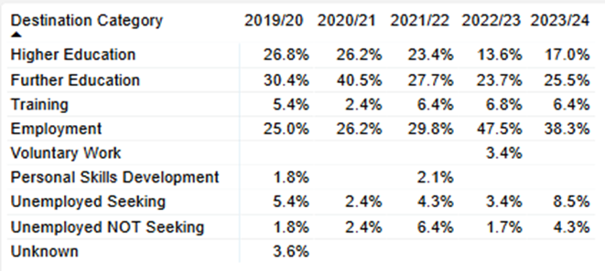

National 23/24 Destinations
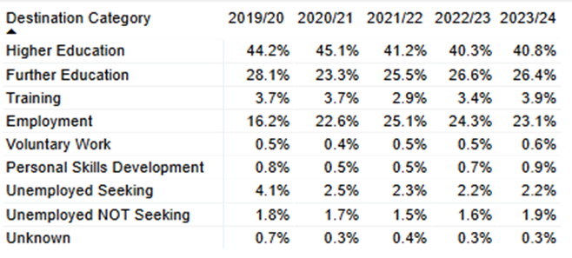

Data Hub – Preferred Routes
Reports on data from the Skills Development Scotland Customer Support System which hosts the Opportunities for All shared dataset. Table below shows Preferred Routes of current S4-6 cohort against Dumfries and Galloway and national figures. Information also available on Anticipated Leave Date and Preferred Occupations.

 | Sanquhar | D&G | National
HE | 34% | 48% | 50%
FE | 22% | 21% | 15%
Employment | 33% | 15% | 12%

Further and higher education is available in Dumfries (33 miles) and Kilmarnock (30 miles).

Work and economy
In 2024, there were approximately 35 private sector business units in Kirkconnel and Kelloholm with this number having remained, largely unchanged since 2020.

Labour market participation is lower in Kirkconnel and Kelloholm than elsewhere in Dumfries and Galloway. The employment-population ratio (proportion of the adult population, people aged 16 years and over, who are in employment) is significantly lower in Kirkconnel and Kelloholm than the rest of the region. 49.4% of those aged 16 plus living in Kirkconnel and Kelloholm in 2022 were in employment, compared to 54.2% of those aged 16 plus in Dumfries and Galloway and 58.2% of those aged 16 plus in Scotland within the same period.

The unemployment rate aged 16 plus (unemployed as a proportion of the economically active population aged 16 plus, employed plus unemployed) in Kirkconnel and Kelloholm in 2022 was 5.2%, compared to 3.2% for Dumfries and Galloway and 4.4% for Scotland within the same period.

The employment rate for working aged people aged 16 to 64 years in Mid and Upper Nithsdale neighbourhood in 2022 was 72.0%, compared to 74.6% for Dumfries and Galloway and 73.3% for Scotland. 25.5% of those aged 16 to 64 years in Mid and Upper Nithsdale neighbourhood in 2022 were economically inactive, compared to 22.9% for Dumfries and Galloway and 23.3% for Scotland.

Workplace-based employment (where jobs are located geographically rather than where employees live) in Kirkconnel and Kelloholm in 2023 was 810, 24.7% lower than 1,075 in 2016, compared to workplace-based employment 1.5% lower in Dumfries and Galloway and 2.7% higher in Scotland within the same period.

There 140 private sector businesses in Mid and Upper Nithsdale in 2024, 9.7% lower than in 2016, compared to 1.6% fewer private sector businesses in Dumfries and Galloway and 0.2% fewer private sector businesses in Scotland within the same period.

4.1% of working aged people aged 16 to 64 years in Kirkconnel and Kelloholm were Claimant Count unemployed (Jobseeker’s Allowance plus Universal Credit Searching for Work regime) in December 2024, compared to 2.9% of working aged people in Dumfries and Galloway and 3.1% of working aged people in Scotland within the same period. 33.8% of working aged people aged 16 to 64 years in Kirkconnel and Kelloholm in December 2024 were on Universal Credit, significantly higher than 18.4% of working aged people in Dumfries and Galloway and 16.7% of working aged people in Scotland within the same period. 266 people and 21.7% of working aged people aged 16 to 64 years living in Kirkconnel and Kelloholm in December 2024 were on Universal Credit with no work requirements (Health or caring responsibility prevents claimant from working or preparing for work).
Housing
Understanding and meeting local housing needs was a recognised priority within the recently endorsed Kirkconnel Parish Place Plan.

The 2011 Census showed that Kirkconnel had the highest percentage of social housing (51.8%) compared to other benchmarked Place Plan towns and it was identified as one of the worst aspects by the community during consultation work undertaken.

A 2019 Needs and Demands Survey, produced to support the development of supported accommodation at Nivison Road, Kelloholm found that 11% of respondents knew someone who had left the village for other reasons, including the lack of supported accommodation and 41% stated that there was need for ‘other types of accommodation’ with all citing ‘Sheltered Housing’.

Kirkconnel and Kelloholm Development Trust with support from South of Scotland Community Housing, Dumfries and Galloway Council and Wheatley Homes South supported the delivery of a community led Housing Strategy. During this work 27% of people said that their current property does not meet their needs and anecdotally, locally, the poor quality of housing provision is often commented upon.

Priorities
Across the three Data zones highlighted four issues are consistent and should be prioritised:

- Population
- Working Age
- Income Deprived
- Employment Deprived

The deprivation experienced in Old Kelloholm is further compounded by its rank in relation to Income domain, Employment domain, Health domain and Education and Skills domain.

Whilst the whole community of Kirkconnel and Kelloholm should benefit from the interventions outlined in this Locality Plan the area of Old Kelloholm must be prioritised and receive further support to address lived experience, given that citizens within this area are within the most deprived 10% of people living in Scotland.

The priorities identified have been cross checked with the Place Plan and the following objectives from the Place Plan were felt to align with actions that that could be delivered through the Locality Plan

- Access to community health and recreational facilities and services.
- Ensuring citizens benefit directly from local renewable energy – jobs, reduced rates, community.
- New local jobs, learning and training opportunities.
- Connecting Kirkconnel and Kelloholm to the outside world – transport, active travel and broadband

Locality Plan – Priority Actions Plan
The primary objective of the Locality Plan is to reduce inequalities therefore it is proposed that the six objectives from the Dumfries and Galloway Poverty and Inequalities Strategy should form the basis of the Themes for the Locality Plan. Four of the Objectives from the Strategy focus on directly delivering specific outcomes for individuals. Two are “enabling” objectives, which will focus on the culture, policy and practice changes that partners will need to make to tackle poverty and inequalities effectively.

Theme 1 - Reducing financial pressures on people facing poverty
Rationale - 33.8% of 16–64-year-olds in Kirkconnel and Kelloholm received Universal Credit in December 2024. In contrast, this is significantly higher than 18.4% of working aged people in Dumfries and Galloway and 16.7% in Scotland.
Action | Desired Outcome | Responsible Partners | Notes / Progress
Explore options to provide targeted learning and training opportunities in the local community. | Travel costs which are a barrier to learning within this Locality will be removed and citizens will have increased opportunities to learn. | DGC Lifelong Learning  SOSE  Dumfries and Galloway College
Weekly Employability, Skills and Partnerships support provided in person from the Hub, Hillview Leisure Centre for both existing clients and members of the public. | Citizens will recognise and feel supported to access job opportunities which will subsequently increase the number of people working within the Locality. | DGC Employability, Skills and Partnerships  Kirkconnel & Kelloholm Development Trust
Targeted parent/carer support events held within the Hub, delivered by Third Sector organisations to highlight the support that is available, with the long-term aim being that with this support in place parents/carers will be in a place where they can be referred into employability support. | Citizens with caring responsibilities will have greater knowledge of the support available to them and be able, in the future, to be supported to enter employment. | DGC Employability, Skills and Partnerships  Kirkconnel & Kelloholm Development Trust  Third Sector Organisations
Affordable activities – Active Schools / Leisure and Sport to target specific individuals / groups children and young people by providing a programme of activity throughout the year. | Children and Young people will have access to activities that are either free or affordable within their community. This will further support citizens to work, knowing children have additional activities available and are within a safe environment. | DGC Education  DGC Leisure and Sport
Online food shopping course / support to enable people to shop online to maximise their available budget. | Citizens recognise the issue of rural inflation and are able to access technology and trust online shopping to maximise their budget. | DGC Lifelong Learning
Dedicated food shopping excursions to more expansive shopping areas. | Delivers a wider choice of product and cost to residents, helping them maximise their financial resources. | Goodshare Foodshare Project (KKDT).  Kirkconnel Parish Heritage Society
Support the operation of the Upper Nithsdale Foodshare Project through continuing their foodshare subscription and access to premises. | Alleviation of the effects of poverty and food insecurity, reducing the burden of anxiety on residents and contributing to their enablement to improve their own finances | Kirkconnel and Kelloholm Development Trust  DGC Thriving Communities  NHS - Dumfries & Galloway
D&G Winter Warmth Campaign Leaflets and D&G Worrying About Money Leaflets to be distributed to every household within the Locality. | Citizens will have greater understanding of the support available to reduce fuel poverty and fuel debt. Citizens to signposted to further support available to maximise benefits. | D&G Poverty and Inequalities Partnership.  Kirkconnell & Kelloholm Community Council.

Theme 2 - Building individual and community resilience
Rationale - The 2020 SIMD data highlighted Kirkconnel and Kelloholm as being Population deprived.
Action | Desired Outcome | Responsible Partners | Notes / Progress
Work with the community to identify priority Core Path improvements required within the Kirkconnel and Kelloholm area | Citizens health and wellbeing will be improved by having access to good quality, accessible Core Paths. | DGC Environment

Theme 3 - Addressing barriers to accessing services
Rationale – The Locality is our region’s most northernly settlement on the boundary with East Ayrshire Council, suffering from depopulation it considered to be a Remote / Rural community.
Action | Desired Outcome | Responsible Partners | Notes / Progress
Increased advertising of the Dumfries & Galloway Welfare, Advice and Health Partnerships Project which is delivered by DAGCAS at the Mill Hill Health Centre in Kelloholm. | Residents are able to access dedicated DAGCAS One to One Specialist Advisor support within the local GP Surgery.  Increased financial wellbeing.  Reduction in poverty through increasing incomes. | DAGCAS
Reaffirm commitment to retaining the Mill Hill Community Health Centre with citizens accessing General Practice services from both this facility and one in Sanquhar. | Citizens will have access to a GP within their community, supplemented by access from a practice in Sanquhar. | NHS DG
Explore opportunities for appointments for mental health services, physiotherapy etc. to be delivered from the Mill Hill Community Health Centre rather than from Sanquhar. | Citizens will be able to access health services without the need to travel. | NHS DG
Assess opportunities to establish protected appointments at the Sanquhar practice for Kirkconnell & Kelloholm citizens that align with the 221 bus schedule and further assess opportunities for community transport linkages. | Citizens will have access to GP appointments without the need to pay for private taxis to transport them to and from Sanquhar. | NHS DG
Provide Oral Health Clinics within the community, linking with other activities being provided by NHS DG & Partners, to provide preventative oral health advice and refer for emergency clinics / appointments. | Citizens will have increased access to preventative oral health advice. | NHS DG
Review waiting lists for Dentistry in Sanquhar and consider resource input to open up waiting list. | Citizens will have increased access to dentistry. | NHS DG
Explore trusted access or develop a community partnership to support an increase in opportunities at Hillview Leisure Centre. | Citizens will have more opportunities to access Hillview Leisure Centre for services and activities operated by partners, community organisations and volunteers. | DGC Leisure & Sport
Explore with Network Rail opportunities to make Kirkconnel Train Station fully accessible from both platforms. | Citizens who are users of wheelchairs, mobility aids and prams will be able to live locally whilst accessing services, further education and jobs out with their community. | DGC - Sustainable Travel
Dumfries and Galloway Council and Swestrans to investigate better links in and around Kirkconnel and Kelloholm, as well as to Dumfries and Kilmarnock. | Citizens will benefit from an improved public transport schedule, that is better connected, improving opportunities to live locally whilst accessing services, further education and jobs out with their community. | DGC - Sustainable Travel
Ensure the 221 bus provision is maintained and available 6 days per week. | Citizens will benefit from an improved public transport schedule, that is better connected, improving opportunities to live locally whilst accessing services, further education and jobs out with their community. | DGC - Sustainable Travel
Provide public wi-fi at Hillview Leisure centre and promote free access to citizens to reduce the digital divide. Wi-fi is available in parts of the building where the Employability Hub takes place. | Citizens will be able to access the internet freely, opening opportunities for learning. | DGC – Leisure and Sport  DGC – Customer & Digital
Introduce card payment facilities at Hillview Leisure Centre. | Citizens will be able to pay by card locally rather than being required to travel six miles to pay by card for memberships, facilities and services. | DGC – Leisure and Sport

Theme 4 - Building organisation capacity to better tackle poverty
Rationale - The Locality is one of the places where the most deprived 20% of people in Scotland live.
Action | Desired Outcome | Responsible Partners | Notes / Progress
Explore opportunities to build new homes through an Assessment of vacant publicly owned land / property which may be suitable for building new homes | Land identified for possible mixed social / private housing.  Increased housing stock will repopulate the locality. | Registered Social Landlords  Property Services / Strategic Housing / Planning Services – DGC  NHS D&G

Theme 5 - Maximising income of people facing poverty
Rationale - The Locality SIMD Data highlights Employment Deprivation as the worst ranking across all measures.
Action | Desired Outcome | Responsible Partners | Notes / Progress
Increased advertising for Dumfries & Gallway Citizens Advice Service current drop-in Provision delivered from the Kirkconnel and Kelloholm Development Trust which is currently delivered on a weekly basis. | Citizens will have greater awareness of the support available from DAGCAS locally. | DAGCAS  D&G Poverty and Inequalities Partnership Sub-Group 2
Investigate with the Lemon Aid Fuel Poverty Project the possibility of securing funding to provide a dedicated Fuel Poverty drop-in provision within the Locality. | Citizens would receive enhanced support and advice regarding fuel poverty. | D&G Poverty and Inequalities Partnership Sub-Group 2  Lemon Aid
Explore opportunities for all Financial Wellbeing Providers to deliver services on a drop in basis within the Locality. | Citizens will have greater access to financial advice. | D&G Poverty and Inequalities Partnership

Theme 6 - Tackling severe and persistent poverty and destitution
Rationale - % of Children in Poverty Profile report at 22% 2020/21, now at 36.1% in latest data point (2021/22)
Action | Desired Outcome | Responsible Partners | Notes / Progress
Targeted cooking for beginners’ courses, enabling surplus food to be used within meals.  Information sessions to support portion control, nutrition and healthy lifestyles. | Citizens learn how to cook low-cost healthy meals with basic ingredients and become confident in their ability and creativity. | DGC Lifelong Learning  NHS Dumfries and Galloway  Kirkconnel and Kelloholm Development Trust
Increase education input around employment and enhance the relationship with local employers. | Child and Young People recognise the value of work and aspirations of young people are increased. | DGC Education
Establish additional support for those who wish to develop their learning. | Young people will have further opportunities to learn and achieve their full potential. | DGC Education

Monitoring and Evaluation
The Community Planning Partnership Senior Leadership Team will receive six-monthly Monitoring Reports on the actions identified. Where actions identified would benefit from individual evaluation this will be undertaken by the lead service / organisation and reported through the same process with opportunities every six months.

Locally community organisations will be engaged throughout this process with opportunities provided on an annual basis for partner organisations to provide feedback on the actions undertaken at that point.

A full evaluation of the Locality Plan can be undertaken towards the end of the programme period (2030) and reported both to the Community Planning Partnership and to the local community through a variety of means.

Contact

Fiona Daubney
Ward Manager Mid and Upper Nithsdale
Dumfries and Galloway Council
E: Fiona.Daubney@dumgal.gov.uk
T: 07500839619

Appendix

Assets
Fixed Assets | Service Based | Civic Based
Kelloholm Primary School & Nursery - DGC  Kirkconnel Miners Memorial Centre - DGC  Hillview Leisure Centre - DGC  Mill Hill Health Centre - DGC  Four Play parks one being inclusive - DGC  DGC Customer Service Centre - DGC  DGC Adult Resource Centre - DGC  Food Share premises - NHS  Church of Scotland (due to close Sept 2025)  Gospel Hall  Community Church  Masonic Hall  Kirkconnel Parish Heritage Society (KPHS)  Action for Children  Bowling Green and Club  Scout Hall  Cadet Hall  The Cabin  Three local shops, Two Post Offices  Butchers  Chemist  Takeaway  Train Station  Brown Brothers Meat Processing Factory  Dog Groomers  Hotel | Kirkconnel and Kelloholm Community Council  Kirkconnel and Kelloholm Development Trust  Kirkconnel Parish Heritage Society  Walking group  Women’s group  Action for Children  Kirkconnel and Kelloholm Children Gala  DGCAS (paid for with external funding one day per week)  Youth Work once weekly - DGC  Lifelong learning activities - DGC | Brighten up Kirkconnel an Kelloholm  Kirkconnel and Kelloholm Children’s Gala  Kirkconnel and Kelloholm Community Council Christmas Festivities, Armed Forces week and day events  Check and Chat

A Borderlands Inclusive Growth Deal place plan by CEIS for Kirkconnel and Kelloholm Town Team, 2023 Strantec for South-West of Scotland Transport Partnership (Swestrans), 2022 https://simd.scot/

