Local Outcomes Improvement Plan – End of Year Report – 2024-2025
Community Planning Partnership Board Overview
During 2024/25, the Community Planning Partnership Board (CPPB) maintained the oversight and leadership for the implementation of our Local Outcomes Improvement Plan 2023 -2033 and also provided support and direction to our more recently established Community Planning Senior Leadership Team (CPSLT).
Local Outcomes Improvement Plan (LOIP) and Locality Plans | Community Planning
This led to a “LOIP Action Plan” being developed to provide partner focus around a number of identified priority work areas as follows:
- Anchor Organisations | - Digital
- Community Wealth Building | - Climate
- Tobacco and Vaping | - Reducing the disability employment gap
- Locality Plan | - Review of Plans/Strategies which contribute to our Community Planning model

Whilst four projects are still underway, four projects have been completed/are close to being completed and a summary of these is provided as follows:

Anchor Organisations
Anchor Organisations: Strengthening Our Role in Community Wealth Building
This work was led by the Director of Public Health, with support from Public Health Scotland (PHS). All Community Planning (CP) partners undertook a self-assessment using the PHS framework:
Harnessing the power of anchor institutions: a progression framework for Scottish organisations - Publications - Public Health Scotland
Key Insights:
- Improved Understanding: All CPP partners gained a clearer understanding of what it means to be an anchor organisation and the role they can play in supporting local communities.
- Existing Strengths: The assessment confirmed that partners are already engaged in a wide range of anchor activities.
- Identifying Gaps and Opportunities: The process helped highlight areas where anchor work could be strengthened. It also identified examples of best practice—such as Dumfries and Galloway Council’s leadership in community asset transfers, which earned a CoSLA Excellence Award—offering valuable learning opportunities for other partners.
- Focus on Procurement: One key area identified for development is procurement—specifically, how the buying of goods and services can be better aligned to benefit the local economy.

What’s Next?
- Each CPP partner will reflect on their own anchor actions and identify opportunities to enhance their contribution.
- Collectively, the CPP will explore ways to build community wealth by strengthening local procurement practices.
- A case study highlighting this work is being prepared for sharing on the Public Health Scotland national website.

Community Wealth Building (CWB) in Dumfries and Galloway

South of Scotland Enterprise (SoSE) facilitated a series of five workshops, each focused on one of the five key pillars of Community Wealth Building (CWB). These sessions aimed to build a clearer picture of current CWB activity across the region and to support the development of a more coordinated and strategic approach.
Key Areas Explored:
- Fair Work: Exploring the future use and regional application of the Fair Work assessment tool.
- Community Assets and Local Data: Reviewing data on Community Asset Transfers, Local Place Plans, and Scottish Land Fund grant awards to understand local trends and opportunities.
- Inclusive Ownership: Identifying partner priorities around inclusive economic models, including support for the 239 social enterprises currently operating in the region.

What’s next?
A key objective of this work was to prepare for the formal introduction of the Community Wealth Building legislation, with the Community Wealth Building (Scotland) Bill being introduced on 20 March 2025 and is at “stage 1” of the process of becoming an Act. The insights gathered through these workshops will inform future planning and action across the region.

Tobacco and Vaping: Youth Concerns and Local Action
In 2023, the 10,000 Voices consultation with young people, led by the Council’s Youth Work team, identified tobacco and vaping as the top priority issue facing young people in Dumfries and Galloway.
At the joint Community Planning Partnership Board (CPPB) meeting with the Dumfries and Galloway Youth Council in September 2024, it was agreed to:
- Develop a local position statement on tobacco and vaping
- Send formal letters to both the UK and Scottish Governments expressing concern about the growing impact of vaping on young people
Board Papers - Community Planning Partnership Board - 13 September 2024.pdf
This action helped raise the profile of the issue locally and nationally. A supportive response was received from Jenni Minto, Scottish Minister for Public Health and Women’s Health, acknowledging the concerns raised.
To support frontline engagement, a training and awareness package has also been developed to help practitioners have informed, supportive conversations with young people about tobacco and vaping. This is available to access here: https://youtu.be/aO_7GDXPy8A

Locality Plan Development
Following the 2023 review of Community Planning, a new approach was agreed to better target areas of need across Dumfries and Galloway. In collaboration with Public Health Scotland, data was analysed to identify communities experiencing the highest levels of deprivation.
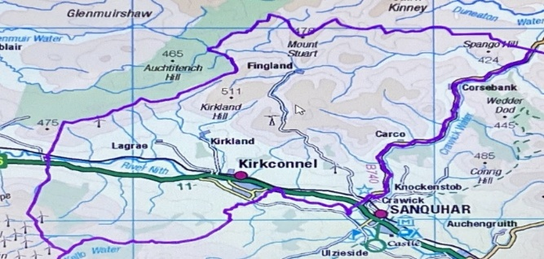
As a result, the Community Planning Partnership Board approved the development of a pilot Locality Plan for the Kirkconnel and Kelloholm area. This plan will focus on tackling inequalities through targeted actions across key priority areas, ensuring a place-based approach that reflects local needs and aspirations.
Priorities were focused around the key themes outlined in our Community Planning Poverty and Inequalities Strategy:

Theme 1 – Reducing financial pressures on people facing poverty | Theme 2 – Building individual and community resilience
Theme 3 – Addressing barriers to accessing Services | Theme 4 – Building organisation capacity to better tackle poverty
Theme 5 – Maximising income of people facing poverty | Theme 6 – Tackling severe and persistent poverty and destitution

Locality Planning in Action
Local officers collaborated closely with the community to review relevant data and existing plans for the area. This process helped identify key projects and activities that could effectively address local inequalities.
From this engagement, a set of realistic and achievable actions was developed in partnership with relevant organisations. These actions were incorporated into a Locality Action Plan, which received formal approval from the Community Planning Senior Leadership Team on 4 July 2025.
In addition to Kirkconnel and Kelloholm, other areas identified as priorities for future Locality Plans include parts of Annan, Dumfries, and Stranraer.
Community Planning Partnership Board - Key achievements
- Maintained a rotating Co-Chairing arrangement between the Council and NHS;
- Endorsed the Dumfries and Galloway Children’s Right’s Report 2020-2023 and agreed how CP partner input could be integrated into the next report;
- Provided comment and feedback on the development of a new Housing Strategy and committed resource to the Housing Emergency Action Plan;
- Contributed to the development of a new Physical Activity Strategy for our region;
- Engaged in facilitated discussion around the work of the Poverty and Inequalities Partnership and Resettlement Board;
- Considered findings and improvement actions stemming from the Education Scotland Community Learning and Development Progress Visit to Dumfries and Galloway in January 2024;
- Provided support and direction to the development of the Local Development Plan 3;
- Supported and contributed to a “Re-Population” project in response to “Tackling Scotland’s Population Challenges;”
- Supported the COVID Remembering Together Project;
- Held a Joint meeting with the Dumfries and Galloway Youth Council and agreed joint improvement actions;
- Considered how the CPP can support the new Regional Economic Delivery Plan for 2025-2027;
- Engaged in discussion around the Alcohol and Drugs Partnership Annual Report;
- Considered support for Fair Funding for the Third Sector;
- Contributed to the consultation on the Population Health Strategy;
- Submitted an application to be part of the Collaboration for Health Equity Scotland project;
- Supported the establishment of a D&G Cultural Partnership and associated Delivery Plan;
- Participated in the Improvement Services’ Community Planning self-evaluation exercise and development of an agreed an action plan.

How are we doing?*
*see the appendix for detailed breakdown of indicator trends
THEME – HEALTH AND WELLBEING
Regional Health and Wellbeing Overview
The ongoing Cost of Living crisis continues to significantly affect families across Dumfries and Galloway. The region currently experiences fuel poverty levels above the national average, with an upward trend indicating growing concern. Child Poverty rates have been above the national average, however latest data for 23/24 has shown a decline to 22.7% the lowest level since 2015 when records began. While median earnings remain below the national average, the earnings gap has narrowed slightly since 2020/21. In terms of health indicators:
- Healthy Life Expectancy (HLE) presents a mixed picture:
- For females, there is a worsening trend over the past three years.
- For males, HLE has remained relatively stable and above the national average.

- Alcohol related hospital admissions are showing a declining trend, with Dumfries and Galloway performing better than the national average. However, there has been a slight increase in alcohol related deaths between 2019/20 and 2023/24, though rates remain well below national levels.

- Drug related deaths rose between 2020/21 and 2022/23, but encouragingly, there was a sharp decline in 2023/24, bringing the rate well below the national average.

- Child Healthy weight - D&G has had a lower percentage of children of a healthy weight compared to the reset of Scotland but the latest data has shown increases in the percentage of children of a healthy weight.

Examples of successful projects linked to Health and Wellbeing:
Child Poverty
Key Successes - The most recent Local Child Poverty Action Report published in November 2024 highlighted the following achievements:
• 348 clients were supported to obtain financial assistance to the value of £220,000.
Of these, 95 clients had a successful intervention which prevented their situation progressing to eviction, with an average Homeless case costing the local authority £12,000 this potentially saved a total of £1.14 million.
• School clothing grants provided for 2,215 local children and young people and over 650 children and young people were assisted with ‘back to school’ and separately ‘warm winter’ clothes. Over 5150 items of school uniform and 3500 items of donated warm winter clothing were distributed at 7 events across the region.
• An expansion of the opportunities to access free sanitary products across council, health and third sector partners sites, with thousands of local families benefiting from the service.
• Dumfries and Galloway Council works in partnership with Dumfries and Galloway Citizens Advice Service to provide information services throughout the region. The LCPAR noted that this commission delivered income maximisation measures resulting in additional income of over £9.5 million for 3348 clients.
• The Youth Work team supported young people to produce a short film “Through Young Eyes” which explores how young people in our region perceive poverty and their own lived experience of poverty. "Through Your Eyes" Launches | Dumfries and Galloway Council. This was shared across CP partners and with Jenni Minto, Minister for Public Health and Councillor Paul Kelly, COSLA spokesperson for Health and Wellbeing at their visit to the CPP in November 2024.

Challenges/Issues
Following the most recent Child Poverty data being made available in July 2025, it highlighted that child poverty in Dumfries and Galloway has reduced from 26.9% in 2022/23 to 22.7% in 2023/24 and just below the national average which sits at 23%. During 2024 the Child Poverty subgroup undertook a service design led review workshop to understand how the group might support the achievement of better outcomes, work better together rearticulating the group purpose, vision and commitment and setting out next steps which included:
- Aligning the reporting functions of the subgroup to streamline work enabling a focus on impact and building on the themes identified in the workshop which were Direction, Partnership, Resources, Roles, Rurality and Humanity.
- Further developing the enabling and supporting actions with a focus on realistic measures, a responsive but not reactive partnership approach all building on the voice of lived experience.
Dumfries and Galloway Council Policy investment funding(£1.8M) taken forward through a range of Community Planning Partners. N.B. The following is a summary of 3 key projects which were evaluated using the “6 attributes for evaluation” approach which was developed using the RADAR European Foundation for Quality Management (EFQM) Model. The full evaluation report is available here: End of Year Evaluation - Appendix 1 - Final.pdf
Cost of Living
Welfare and Housing Options (£165,000)
Sound | Implemented | Results
This project is to support the Welfare and Housing Option (WHO) Support team to provide a seamless service which helps clients to sustain their tenancies, prevent evictions and address and reduce all debts. From April 2025 onwards, this Project will be moved to mainstream Dumfries & Galloway Council Funding. | Implemented to a huge range of customers requiring different support from tenant grants, discretionary housing payments (DHP), council tax reduction and crisis and homeless prevention grants. The Project continues to be implemented by specialist advisors to a huge number of customers requiring different levels of support which includes homeless prevention grants, discretionary housing payments, council tax reduction grants, crisis grants, housing payments, tenant grants along with additional support to maintain their tenancies. | In 2024/25 the Welfare and Housing Options team have assisted 396 clients. Assistance has been provided to address rent arrears and potential eviction. Clients have been helped to claim additional benefits with a value of £723,000, and address debts in other areas, such as Council Tax. A detailed case study highlighted the impact on a customer receiving support that included a wide range of support which is normal for every case completed. The customer advised this had been a huge and heavy rucksack on their back for so long and it had been lifted, and they could never repay and thank us enough for all the support and in clearing these arrears. It gave them an opportunity of a fresh start.
Fareshare Membership for Community Groups (£56,000)
Sound | Implemented | Results
To continue to provide Fareshare membership to 19 organisations throughout our Region with a total of 17 community groups in D and G supported providing surplus nutritious food from Fareshare. This Project provides surplus food on a weekly basis to Food Providers throughout our Region | Deployed across Dumfries and Galloway in different areas to create better balance of provision for customers. Fareshare Memberships were originally allocated with the aim to cover all areas of our Region. This provides a higher level of provision of surplus food than would otherwise be available within each area who benefit from Fareshare Memberships. | The Project results for 2024/2025 are as follows: Over 219 tonnes of food delivered through Fareshare, which in turn enabled foodbanks to provide essential supplies for 522,448 meals. This is an equivalent food costs of over £816, 670 with 211 tonnes of food diverted from landfill  The project is making a significant impact with foodbank users/customers who are single parents/ and working part time. Providing a range of food that otherwise wouldn’t be possible given rise in costs of food in supermarkets along with increasing their capacity to cook has helped shield the families from more financial challenges. Fairshare continues to make a significantly large impact and reduction on food insecurity within our region.
Summer of Play programme for Children and Young People (£264,000)
Sound | Implemented | Results
The Summer of Play offer specifically targeted children and young people who sit within the six priority groups as included within our region’s Children’s Poverty Plan. All funding was used to distribute grants to Third Sector organisations and Council Services to run Summer activity programmes in local communities across Dumfries and Galloway. Grants were distributed following an application process, and applications were scored by an independent scoring panel. | The activities on offer were across all 12 Ward areas with a focus on food provision, were entirely free to access, as well as ensuring that this work was targeted towards children and young people from low income and vulnerable households, and also those who sit within the 6 - priority groups as identified in our regions Child Poverty Plan. Summer of Play supported 36 Third Sector organisations and 6 Council services to provide activities and programmes for our region’s most vulnerable children and young people. As well as Service provision, the funding has also been used for significant investment into local communities and to support organisations and their staff | Through the Monitoring and Evaluation Reports that were submitted as part of the fund, we know that 9,417 unique children and young people in Dumfries and Galloway took part in at least one of the activities on offer. We were also able to look at the target groups as identified within the Children’s Poverty Plan who accessed activities ran using Summer of Play funding: Lone Parent Families: 27% Families which include a disabled adult or child: 25% Larger Families (3 or more children): 23% Minority Ethnic Families: 8% Families with a child under 1 year old in the household: 12% Families where the mother is under 25 years of age: 5% The Summer of Play funding scheme has provided organisations with the means to do a significant amount of work in order to provide support and opportunities to our region’s most vulnerable children and young people.

Mental Health support taken forward through Children’s Services Strategic and Planning Partnership
Since the Covid-19 pandemic, demand for mental health support has increased both locally and nationally. We have seen more referrals to the School Nursing Service on mental health grounds, and we have more children and young people who are not attending school for anxiety-related reasons.
Actions
1. To ensure that all children and young people have access to the mental health and wellbeing support that they need when they need it. This includes a breadth of access, close to home and in a timely manner, matched to the needs expressed:
• Development of a Mental Health Pathway
• Development of web-based resources based on engagement with children, young people and parents/carers
• Addressing national priorities including the implementation of a range of low-level mental health and psychological approaches.
2. To ensure the recognition and early intervention for perinatal mental health issues and to improve access to psychological and mental health services. This includes:
• Development of an integrated care pathway that addresses identified gaps in specific areas – this is about addressing identified gaps, like support for birth- trauma and baby-loss, and working with service-users to identify further gaps and shape services.
The Mental Health Pathway was finalised during the reporting year, and is available here. Mental Health Pathway
Within the reporting period there have been events to launch the Pathway with different professional groups across our Children’s Services partnership, and these will continue into the next reporting year. The Children Adolescent Mental Health Service (CAMHS) website is operational and this action can be signed off as complete CAMHS – Dumfries & Galloway Health & Social Care. Work is now taking place in the 2025-26 reporting period on access to online low level mental health interventions for children and young people. Youth Counselling in Schools continues to operate, with evaluation reports on this work available here:
About low-level mental health support in schools | Dumfries and Galloway Council

During the reporting year, a Health and Wellbeing public website has been launched, which includes specific areas just for education staff – this incorporates the Rights Respecting Schools approach and focuses on:

- Assessment of pupil wellbeing
- Resources to support the Health and Wellbeing curriculum
- Promoting Attendance
- Signposting to services within the mental health pathway
- A termly Health and Wellbeing newsletter signposts staff to new resources.

Key successes this year have included:
- Embedding of the Mental Health Pathway
- The continuation of Counselling in Schools
- Improved access to mental health supports for parents and babies

Alcohol and Drugs Partnership (ADP) – role out of Naloxone
Increasing Naloxone Provision
Naloxone can temporarily reduce the effects of an opiate overdose and prevent an overdose from becoming fatal. The Naloxone Working Group of the ADP meets every three months to promote the provision of “Take Home” Naloxone Kits across the region.
In 2023/24, Dumfries and Galloway ADP distributed 707 Take Home Naloxone Kits.
- Across Dumfries and Galloway, 252 police officers and 10 fire officers have been supplied with emergency Naloxone. This can be administered if they encounter someone who is experiencing a near fatal overdose.
- Community pharmacies across the region can now supply and administer emergency Naloxone kits.
- The custody suite can now distribute Naloxone.
- The Specialist Drug and Alcohol Service and “With You” also provide naloxone kits.

Health and Wellbeing Case Studies
Case Study 1: Active Lives Pathway
Which LOIP Outcome(s) does this contribute to?
- 3. Improve the health and wellbeing of our citizens through targeted approaches.
Why is this project important?
Being physically active and maintaining muscle strength and balance is vital for independence and fall prevention. Yet, 74% of Scottish adults don’t meet recommended physical activity and strength guidelines—equating to around 93,000 people in Dumfries and Galloway. Additionally, 22% of adults in the region are active for less than 30 minutes per week.

What did we do?
In November 2023, the Health and Social Care Partnership and Dumfries and Galloway Council launched the Active Lives Pathway (ALP). This free, community-based programme helps individuals referred by health and care professionals become more active. ALP supports early intervention and aligns with national priorities set by the Scottish Government and Public Health Scotland.

What has the impact been for the population?
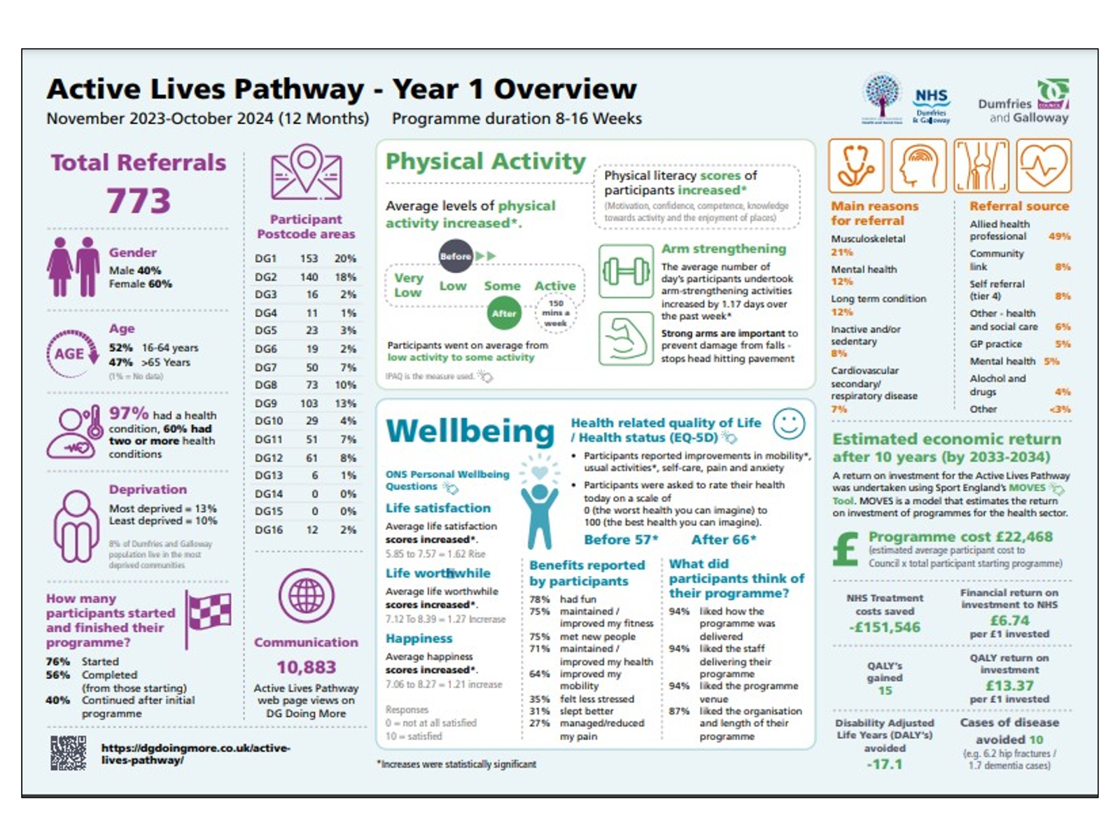

What impact has the project had on individuals?
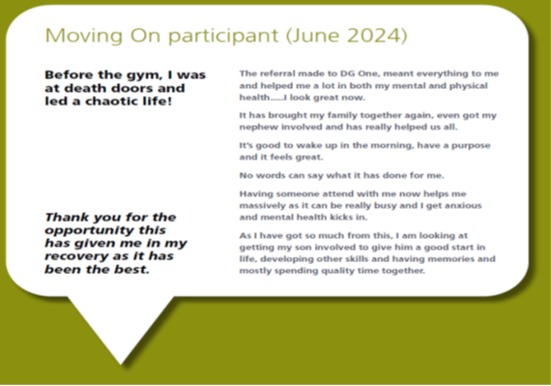

Case Study 2: Tackling Fuel Poverty in Dumfries and Galloway
LOIP Outcome 1: Help mitigate the impacts of the Cost of Living for those who are affected most
Background
Dumfries and Galloway faces disproportionately high levels of fuel poverty, with 37% of households affected—well above the Scottish average of 31%. Contributing factors include a high number of single pensioners, older housing stock, and 39% of homes being off the gas grid, relying on costly heating fuels like oil and LPG.
Project Overview
In response, the Dumfries & Galloway Poverty and Inequalities Partnership launched the Winter Warmth Project in November 2024. The initiative aimed to reduce fuel poverty through awareness, support, and direct aid. Key partners included:
- Lemon-Aid Fuel Poverty Project
- Dumfries and Galloway Council
- Citizens Advice Service
- Home Energy Scotland
- Scottish Fire and Rescue
- Third Sector Dumfries & Galloway
- Social Security Scotland
- NHS Dumfries and Galloway
Actions Taken
- Distributed 80,000 easy-read leaflets offering advice and contact details for support services.
- Targeted outreach to older residents with tailored messaging.
- Ran a media and social media campaign, featured on ITV and Border News.
- Provided winter warmth items including heated blankets, gloves, and mugs.

Impact
One notable success involved a self-referred resident struggling with energy debt. Through Lemon-Aid:
- A home visit was arranged to assess her situation.
- Accurate meter readings were submitted to her energy supplier.
- Applications for support resulted in £3,500 in grants, clearing her debt and leaving her account in credit.
- The resident reported improved mental and physical health, reduced anxiety, and better understanding of her energy usage.

Outcome
This project directly supports LOIP Outcome 1: Help mitigate the impacts of the Cost of Living for those who are affected most, by addressing fuel poverty and improving wellbeing for vulnerable residents.
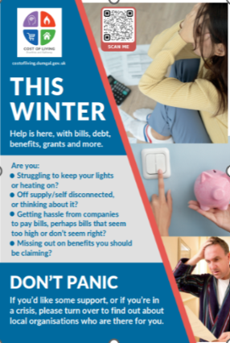 | 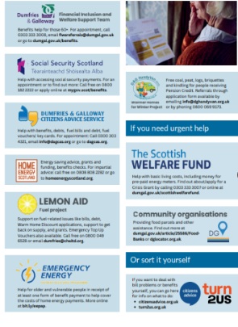 | 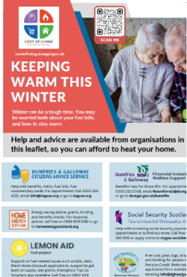 | 

THEME - WORK
Summary
Employment and Economic Participation Overview
The participation rate measures the proportion of 16–19-year-olds entering employment, education, or training after leaving school. In 2024—94.4% of those aged 16-19 in Dumfries and Galloway were in positive destinations which is above Scotland at 92.7% and the highest rate on record since 2016, reflecting strong progress in youth engagement.
Job Market Activity: Job advertisements surged by 23.7% year-on-year and were 83.1% above 2019 monthly averages—more than double Scotland’s increase.
Employees pay increased by 2.5% in real terms in the year to January 2025, the highest increase of all Scottish areas.
In Dumfries and Galloway 19% of those aged 0-15 years lived in relative low-income families in 2024 - minus 1.3 percentage points from 20.3% in 2023.
However, several challenges remain under consideration:
- The percentage of workless households has reached a five-year high, currently sitting at 24.4%, significantly above the national average of 17.4%.
- While there has been some improvement in the proportion of people earning the Real Living Wage or more, the region still lags behind the national average.
- The percentage of residents receiving out-of-work benefits has increased over the past two years and is now 1% higher than the national average.
- Disability Employment Gap: At 42.2 percentage points, Dumfries and Galloway had the third highest gap in Scotland, significantly above the national average (30.7 p.p).

Examples of positive activity to support the theme of “Work”
Employability, Skills and Partnerships
- Through No One Left Behind and UK Shared Prosperity Funds DGWorks was able to commission provision from public, private and third sector organisations across Dumfries and Galloway focusing support on tackling poverty, economic activity, the disability employment gap and on supporting young people who have experienced care.
- Dumfries and Galloway Local Employability & Skills partnership (LEP) commissioned provision through the DG Works brand supported 1297 people in 2024-2025. Positive outcomes during 2024-25 included:
  - Employment 202
  - Apprenticeship 5
  - Self-employed 22
  - Full time education 56
  - In work progression 6
From Hesitation to Hustle – Empowering a Local Entrepreneur to Launch a Gardening and Cleaning Business
Individual case study example:
- “C” faced prolonged uncertainty about starting their own business and had little confidence in the viability of their plans. They were previously unemployed and unsure about acting, largely due to self-doubt and lack of practical support. The complexity of this case stemmed from their desire to pursue self-employment in a niche industry without prior structured business experience.
- C’s Triage Key Worker provided support including:
  - Exploring startup costs and financial planning
  - Guidance on pricing strategies and service promotion
  - Help with recordkeeping, client management, and social aspects of business
  - C received ongoing motivation, reassurance, and clear answers to all his operational questions.
- This resulted in a tangible outcome for C of full-time self-employment in Gardening and Cleaning services. C built a clear structure for their business, gained confidence, and began working with autonomy and purpose.
- Last word to C - “I can confidently say that Triage is an organization with professionals who, in my case, provided answers to all my questions, gave me motivation, and boosted my confidence. I am ready to confidently recommend this organisation.”
Increasing income from employment – focus on parents
- Annual increases in the number of parents registered on and receiving support as part of the DG Works pipeline from 193 parents in 23-24 to 421 parents in 24-25 (an increase of 118%)
- Annual increases in parents from the priority families registered on and receiving support as part of the DG Works pipeline:
Priority Group | 23-24 | 24-25 | Increase
Lone Parents | 77 | 164 | 113%
Child with disability | 21 | 43 | 105%
Ethnic minority | 21 | 49 | 133%
Child younger than 1 | 13 | 23 | 77%
Parent with a disability | 17 | 43 | 153%
Young parent | 13 | 34 | 162%
3+ children | 38 | 83 | 118%

- Annual increases in parents registered and receiving support as part of DG Works progressing into employment, work experience, volunteering, education and self-employment. – from 38 in 23/24 to 90 in 24/25 an increase of 137%
Tackling Child Poverty through employment - opening of Stranraer and Kirkconnel and Kelloholm Employability HUBs
The Kelloholm Employability Hub, based at Hillview Leisure Centre and led by the Kirkconnel and Kelloholm Development Trust, is a vital community initiative supported by the DGWorks Innovation Fund. It serves as a central access point for employability, wellbeing, and social inclusion services in a rural area facing significant socio-economic challenges
- 109 individuals engaged including parents, young people, and jobseekers.
- Regular sessions delivered three days a week, offering access to multi-agency support.
- Increased participation in community-led initiatives, including environmental education and softer skills development.
Established in October 2024, the Stranraer Employability Hub was created in response to local needs, identified through service design and community listening. Funded by the DGWorks Innovation Fund, the Hub provides a welcoming, flexible space for individuals, families, businesses, and organisations to connect. To date, the Hub has supported 55 individuals, offering tailored services that reduce barriers to employment and promote inclusive community engagement.
Tackling the Disability Employment Gap
The LEP commissioned Halving the Disability Employment Gap identified five objectives for tackling the disability employment gap including support for school leavers and a role for Dumfries and Galloway’s public sector employers to lead by example.
Placement Plus
Dumfries and Galloway Council has supported Placement Plus – a programme for people to gain paid experience in the workplace whilst also being supported by an employability key worker. The programme covers the cost of up to 30 hours per week for 26 weeks with additional funding for training. For the second iteration of the programme the focus was on supporting those with disabilities. There are 11 participants on the programme which is being independently evaluated.
Whole Family Support to Disabled young people and families
Following the recommendations in the LEP commissioned Halving the Disability Employment Gap report the LEP approved funding for three key workers to provide specialist support for young disabled people in their transition from secondary school into the world of work. The project commenced in October 2024 with key workers providing intensive one to one support and referrals up to 31st March 2025 were:
Area | Referrals
Annandale and Eskdale | 26
Dumfries, Mid and Upper Nithsdale | 35
Stewartry and Wigtownshire | 31

Young people and their families are being supported with a focus on the young person’s transition into positive destinations including volunteering, work experience, education and employment. The project is being externally evaluated and the first phase of evaluation provided very positive feedback from young people, families and schools. The final evaluation will seek feedback from wider stakeholders.
Increasing the Percentage of young adults (16-19 year olds) participating in education, training, or employment

Key Performance Measure | 2019/20 | 2020/21 | 2021/22 | 2022/23 | 2023/24
*Participation rates (those aged 16-19) leaving school and entering employment, education or training | 91.89  (92.13) | 91.9  (92.1) | 93.3  (92.3) | 94  (92.6) | 94.4  (92.7)

*The region has been performing well in this key area with a very positive trend picture over the last 5 years.

This improvement journey has been a result of a comprehensive set of procedures and guidelines being in place to support all schools in ensuring that every young person has access to appropriate post-school opportunities. These measures are aligned with key national policies, including the National Improvement Framework, Curriculum for Excellence, No One Left Behind, and the 15–24 Learner Journey. The overarching aim is to enable all young people to navigate life transitions successfully, achieve personal goals, and develop the skills and confidence needed for their future.

Responsibility for this work sits within the strategic framework for school leavers and is overseen by the Quality Improvement Manager. This role involves close collaboration with School Leads for Employability, Developing the Young Workforce (DYW), Employability, Skills & Partnerships, and Skills Development Scotland (SDS).
The shared ambition is to achieve 100% positive destinations for school leavers. This is managed through:
- Universal support: Delivered by schools and SDS across all phases of education.
- Targeted interventions: Tailored to individual needs from S1 to S6, involving a range of partner organisations.
Together, these efforts ensure that every young person is equipped to make informed choices and transition confidently into further education, training, or employment.

Community Learning and Development (CLD) Partnership contribution to work
The CLD Partnerships brings together various partner organisations who have a role to play in contributing to the CLD (Scotland) Regulations 2013 through the delivery of the CLD Plan. CLD Partners are aligned to providing a range of confidence building and health and well-being supports which progresses into accredited and non-accredited qualifications such as SQA Core Skills in literacy and numeracy; communication and problem solving. All these help to support progression through the stages of the employability pipeline. Through the reporting period:
- 2926 adults recorded improvements in their own mental health and well-being
- 269 adults completed a national accredited award
Through the Employability and Education Workstream of the Resettlement Board, focused support has also been provided to New Scots and Asylum Seekers in terms of learning English through ESOL and gaining recognition for qualifications gained in their homelands, thus helping to support local employment. This has led to:
- 750 referrals being made with 450 ESOL assessments being completed
- An 80% success rate in British Council language tests
- Through the European Network of Information Centres (ENIC) process, 68 learners were supported to secure recognition of degree level qualifications undertaken outwith the Country

Work Case Studies
Case Study 3 – Community Integration
LOIP Outcome Contribution
LOIP Outcome 5: Grow and maximise the potential of the working age population to help increase employability
LOIP Outcome 7: Increase volunteering opportunities to help develop skills, build capacity and support progression into employability
Background
Since the launch of the Homes for Ukraine Scheme in March 2022, 759 Ukrainian guests have been welcomed into Dumfries and Galloway. The Lifelong Learning Service, in partnership with the Dumfries and Galloway Resettlement Board, has played a key role in supporting these individuals through ESOL (English for Speakers of Other Languages) and other adult learning opportunities.
Project Overview
To support integration, a structured ESOL learning pathway was developed in collaboration with Dumfries and Galloway College. The programme also included courses in creative writing, driving theory, digital skills (ICDL), and volunteering/job readiness, helping learners build confidence and practical skills for life and work in the region.

Case Study Focus: Olha Chesnova

Olha arrived in Dumfries and Galloway in 2023 with limited English and low confidence in her digital and professional skills. She enrolled in multiple courses, including:  - ESOL Speaking  - IELTS Preparation  - Creative Writing  - Driving Theory  - ICDL (Computer Skills)  Through regular attendance and active participation, Olha significantly improved her English, digital literacy, and confidence. Her learning journey led to:  - Volunteering opportunities  - Securing paid employment  - Achieving economic independence  - Gaining her own tenancy  - Her son’s full integration into a local school  Olha now contributes to her community not only through work but also by volunteering at a local foodbank and supporting others on their resettlement journey.  Impact  This project directly supports community integration by empowering individuals with the language, skills, and confidence to thrive. Olha’s story is a powerful example of how targeted support and inclusive learning can transform lives and strengthen communities. | 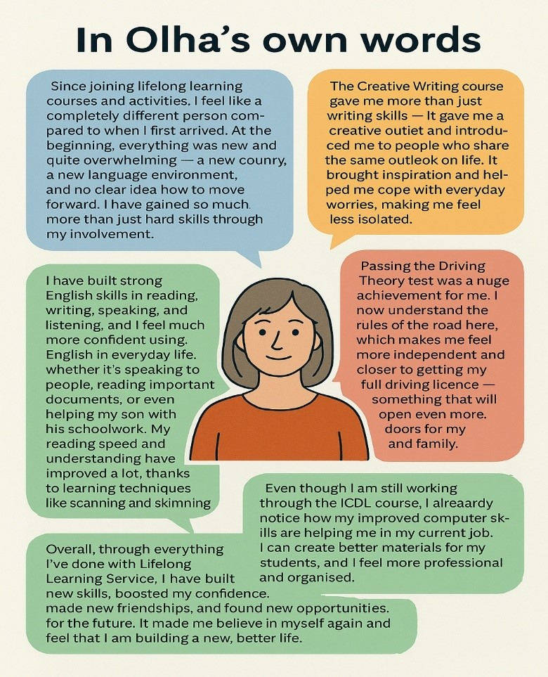

Case Study 4: Volunteering for Community Empowerment – Learners Together Forum
LOIP Outcome Contribution
LOIP Outcome 7: Increase volunteering opportunities to help develop skills, build capacity and support progression into employability
The Learners Together Forum, established in 2018 by the Lifelong Learning Service, empowers adult learners across Dumfries and Galloway to shape their own educational experiences. Volunteers from four ward areas actively contribute to identifying learning needs, co-designing course content, and advocating for inclusive, accessible education.
Why It Matters
Co-designing learning with adult learners ensures:
- Relevance: Courses reflect real-life needs and community priorities.
- Empowerment: Learners gain ownership and confidence.
- Inclusivity: Barriers such as language and access are addressed.
- Community Strength: Collaboration fosters resilience and connection.
- Sustainability: Programmes are more likely to endure and evolve.
What We Did
Forum volunteers play a vital role in:
- Identifying local learning needs
- Shaping course content and delivery methods
- Collaborating with tutors and coordinators
- Evaluating and improving existing programmes
- Championing inclusion for marginalized groups
Their efforts have helped secure over £90,000 in external funding, enabling a wide range of community learning opportunities, including:
- Literacy and numeracy classes
- Art and craft sessions for mental wellbeing
- Digital skills training and device access
- Cooking and First Aid classes
- British Sign Language courses
- Family events and free children’s books
- Publication of adult learners’ books
Impact on Individuals
Forum volunteers benefit from:
- Skill development in leadership, communication, and problem-solving
- Confidence building through active participation
- Social connection and reduced isolation
- Influence in shaping inclusive education
- Pathways to further opportunities in volunteering, training, and employment
- Sense of purpose and pride in supporting community learning
In 2023, the group’s achievements were nationally recognized with a learning award, celebrating their commitment to empowering communities through education.

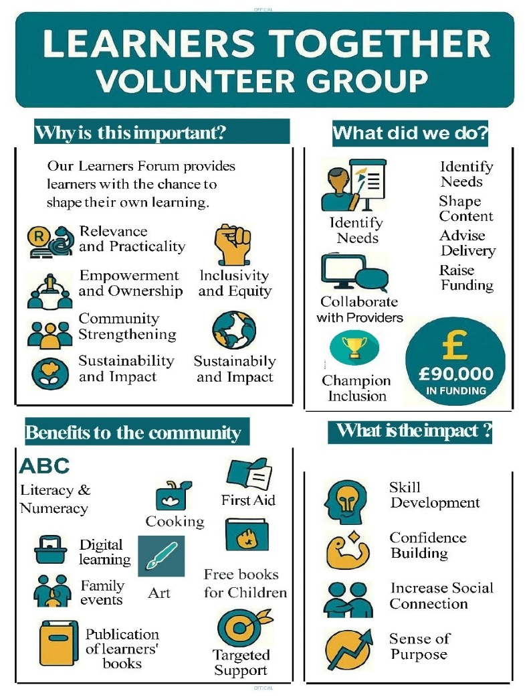 | 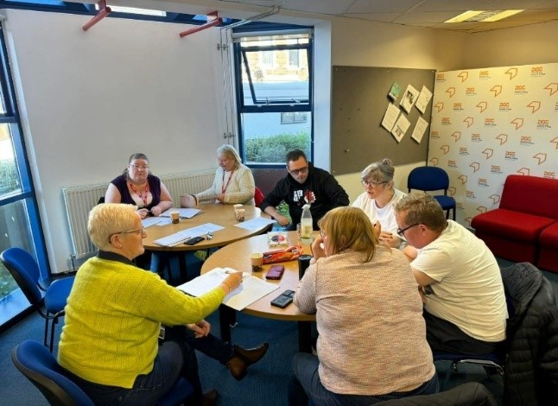

THEME – WHERE WE LIVE (PLACE)
PLACE OVERVIEW
Dumfries and Galloway continues to face challenges compared with other local authority areas. Although full fibre broadband coverage is increasing – currently at 26% - it remains significantly below the national average. Additionally, the proportion of business premises unable to access broadband speeds of at least 10Mbps is 2% higher than the national average, highlighting ongoing digital connectivity issues.
Access deprivation is another key concern. The latest SIMD data shows that 33.31% of the population live in the 15% most access-deprived areas – twice the national average. This reflects the differences rural communities face in accessing employment, education, healthcare, leisure, and transport services.
On a more positive note, recycling rates have improved significantly over the past 5 years and are now approaching the national average. Similarly, the proportion of households with an environmental certificate rated “C” or above has increased by 9% over the same period. However, this still sits 15% below the national average, indicating further scope for improvement in energy efficiency.

Examples of Climate related activity

Natural Capital Innovation Zone (NCIZ)
The NCIZ is a Scottish Government designation covering the South of Scotland, officially awarded in 2024. It positions Dumfries & Galloway and the Scottish Borders as a “living lab and learning hub” for climate and nature-positive innovation. The NCIZ is designed to accelerate solutions to biodiversity loss and climate change, supporting a green, fair, and flourishing regional economy.
Key features include:
Landscape-scale nature-based solutions: Investment and innovation address market failures and create new opportunities, shifting traditional economic models towards a wellbeing economy.
Guiding principles: Circular Economy (designing out waste and regenerating nature), Creativity (arts, storytelling, and innovation to shift culture), and Community Wealth Building (ensuring local people benefit from nature-positive change).
Collaborative partnerships: The NCIZ is being driven forward by SOSE and delivered through strong cross-sector partnerships, including local authorities, third sector organisations, and community groups, and is an initiative that developed from the Borderlands Inclusive Growth Deal.
Regional Land Use Partnership (RLUP)
The RLUP is the delivery mechanism for the NCIZ, enabling collaborative, place-based decision-making about land use.
Purpose: RLUPs bring together national and local government, communities, landowners, and stakeholders to optimise sustainable land use, addressing climate change and biodiversity loss.
Framework: The South of Scotland RLUP pilot (2021–2024) developed the first Regional Land Use Framework (RLUF), setting out a vision and high-level principles for land-use decisions. This framework aligns with national policy and supports the wellbeing economy, housing, transport, and skills priorities.
Impact: RLUPs facilitate landscape-scale projects, such as riparian woodland, regenerative agriculture, peatland and saltmarsh restoration, and community-led innovation, ensuring that local voices shape sustainable land management.
Natural Capital Training
Natural capital training is being rolled out internally by the Natural Capital team at SOSE, with the aim of building understanding and practical skills among staff. The long-term aim is to also deliver this training to partners.
Content: Training covers the meaning and opportunity of natural capital and the, how to identify and report natural capital projects, and the application of nature-based solutions and circular economy approaches covering everything from small businesses to landscape scale.
Delivery: Developed in collaboration with external experts and tailored to SOSE’s needs, the training includes toolkits, videos, and group activities. It is designed to be engaging and relevant, supporting both internal staff and partner organisations across the NCIZ.
Outcomes: The training is intended to improve reporting, raise awareness, and enable staff to support partners in realising the benefits of natural capital, linking to circularity and net zero.
Circular Economy (CE) Partnership with Zero Waste Scotland (ZWS)
The partnership with ZWS is a critical element of NCIZ delivery, embedding circular economy principles across the region.
Focus: The partnership aims to deepen the evidence base, raise awareness, and address barriers to circularity, aligning with ZWS’s Corporate Plan 2024–2030.
Activities: Awareness raising, linking circularity with natural capital and delivering training packages and resources to embed these principles within business activity, both internally and with clients. Strengthening collaboration between both organisations and identifying opportunities for CE approaches with high impact and scale.
Impact: The partnership supports regional economic bodies, strategic partnerships, and public sector organisations in adopting circular economy practices, boosting productivity, and unlocking investment. It also enables the development of demonstrator projects, such as the Dumfries Zero Waste Park, which supports recycling, waste reduction, and regeneration.

Case Study 5: Community Transport – Connecting Rural Lives
LOIP Outcome Contribution
LOIP Outcome 10: Improve transport connectivity across our region to increase opportunities to access employment, education and leisure, particularly in our most remote rural areas.
Background
Dumfries and Galloway is one of Scotland’s most sparsely populated regions, with just 23 people per square kilometre compared to the national average of 69. Around one-third of residents live in remote rural areas, where public transport is limited and often not commercially viable. This lack of connectivity disproportionately affects low-income and vulnerable individuals, especially those without access to a private vehicle.
Project Overview
To address these challenges, Community Transport Operators across the region joined forces with statutory bodies including NHS Dumfries & Galloway, Dumfries and Galloway Council, and SWestrans through the Community Transport Strategic Development Group. Together, they developed a coordinated approach to improve transport access, particularly for non-emergency patient transport.

What has the impact been for the population?
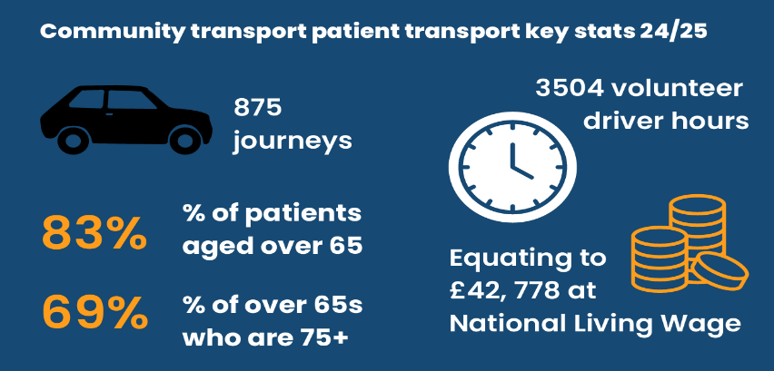
What has been the impact on individuals?
B, an older resident living in a rural area of Dumfries and Galloway, was recently widowed and unable to drive. Living with restricted mobility and dementia, they couldn’t use public transport and didn’t qualify for the Scottish Ambulance Service’s patient transport. With limited income, taxis were unaffordable.
Thanks to Galloway Community Transport, B’s support worker arranged a door-to-door volunteer driver service to take them to a vital health appointment in Dumfries. The driver waited and returned them home safely. Without this service, B would have missed their appointment, potentially worsening their health.
Conclusion
This project demonstrates how community-led transport solutions can bridge critical gaps in rural connectivity, ensuring that even the most isolated residents can access essential services. It’s a powerful example of how strategic collaboration and volunteering can transform lives and support inclusive, equitable access across Dumfries and Galloway.

Case Study 6: Stranraer Borderlands Place Plan – A Community-Led Vision for the Future
LOIP Outcome Contribution:
LOIP Outcome 8: Work with our local communities to develop an inclusive, thriving economy and to promote Fair Work.
LOIP Outcome 11: Work with our communities to help reduce carbon emissions and positively combat Climate Change through education, behavioural change and supporting initiatives which will make a positive difference.
LOIP Outcome 12: Develop high quality, affordable homes to meet identified demand and improve the quality of lives of our communities.

Background
Stranraer was selected as one of five towns in Dumfries and Galloway to benefit from the Borderlands Inclusive Growth Deal. To access funding, a Place Plan was required—one that truly reflected the community’s needs and aspirations. However, local residents were initially reluctant to engage, having experienced years of consultations with little visible impact.
What We Did
1. Connect
A community-focused consultant led the process, starting with deep engagement:
- A launch event at the Millennium Centre
- A six-month information hub
- Outreach to schools, youth groups, clubs, and social groups
- 27 engagement events involving 2,849 participants
- Tools used included the Scottish Government’s Place Standard Tool, ballot papers, and interactive boards
2. Collaborate
Insights were grouped into five key themes:
- Quality of Life
- Work & Opportunity
- Play and Creativity
- Engagement and Climate
- Pride and Citizenship
A Co-Lab event helped identify and ballot six priority projects:
- East Pier Event Space
- Wet Weather Escapes
- The Big Makeover
- Revive: The Big Makeover
- Stanctuary Outdoor Nursery
- Dick’s Hill Wellbeing Hub

3. Co-Design
A Town Team was formed, comprising local stakeholders from business, education, health, housing, and community sectors. This team:
- Oversaw the plan’s development
- Ensured community ownership
- Will continue to guide project delivery

4. Create the Plan
The final Stranraer Place Plan was presented to elected members and the public, followed by a month-long consultation. It has now been approved and will inform the development of the Borderlands Town Investment Plan (BTIP).

Impact
- Community ownership restored through meaningful engagement
- Priority projects identified by the people of Stranraer
- A Town Team established to ensure long-term delivery and accountability
- A clear, community-driven roadmap for investment and regeneration
- Provision of Supported Accommodation for people with Complex Needs
- £710,000 secured from Scottish Government to support two key projects outlined in the Place Plan with a focus on town centre regeneration:

- Town Centre Living – creation of new residential and enterprise spaces in the heart of the town; and
- The Dickshill Community Hub – a new facility designed to service and empower the local community.
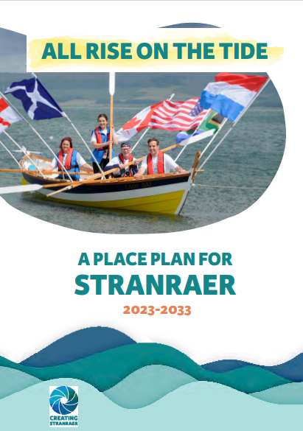 | 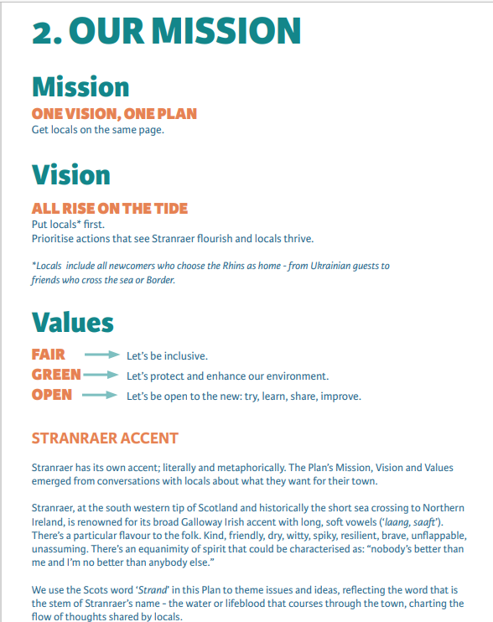

Case Study 7: Housing Investment Plan – Creating Homes for Life
LOIP Outcome Contribution
LOIP Outcome 12: Develop high quality, affordable homes to help meet identified demand and improve the quality of lives of our communities
Why This Project Is Important
Through the Strategic Housing Investment Plan, Dumfries and Galloway Council partnered with Registered Social Landlords (RSLs) and the Health and Social Care Partnership (HSCP) to address a critical gap: the lack of appropriate supported accommodation for people with complex needs.
This initiative aligns with the Integration Joint Board (IJB) Strategic Plan by:
- Shifting care from institutional to community-based settings
- Protecting vulnerable adults
- Making better use of technology
- Ensuring people with complex learning disabilities and/or mental health needs can live in homes for life—adaptable to their changing needs
What We Did
- Three properties were reviewed for suitability. One, privately owned and managed by Progress Care, was identified as a priority for re-provision.
- Turning Point Scotland, the care provider, collaborated with the partnership to co-design a new, purpose-built development for the four residents.
- A second property, owned by Turning Point Scotland in a rural area, was also deemed unsuitable due to its age and location.
- In partnership with Loreburn Housing Association, the Council, Scottish Government, and HSCP, a new development was created in North West Dumfries on the site of a former derelict church.
- The result: 11 accessible bungalows in Lincluden, designed with input from health professionals and families, featuring level access, lower light switches, and other adaptations.
Impact on the Population
- Improved service efficiency: Consolidating three staff teams into one central location reduced travel time and overnight staffing needs.
- Cost savings: Moving to RSL-managed properties reduced rent and Housing Benefit costs.
- Strategic location: Proximity to services and support networks improved recruitment and retention of care staff.
Impact on Individuals
- Residents now live in modern, purpose-built homes that support their independence and wellbeing.
- Homes are equipped with assistive technology and designed to adapt to changing health needs.
- Individuals and families were involved throughout the process, ensuring the homes are truly fit for life.
- The project has future-proofed supported accommodation for a vulnerable group, reducing the need for disruptive moves later in life.
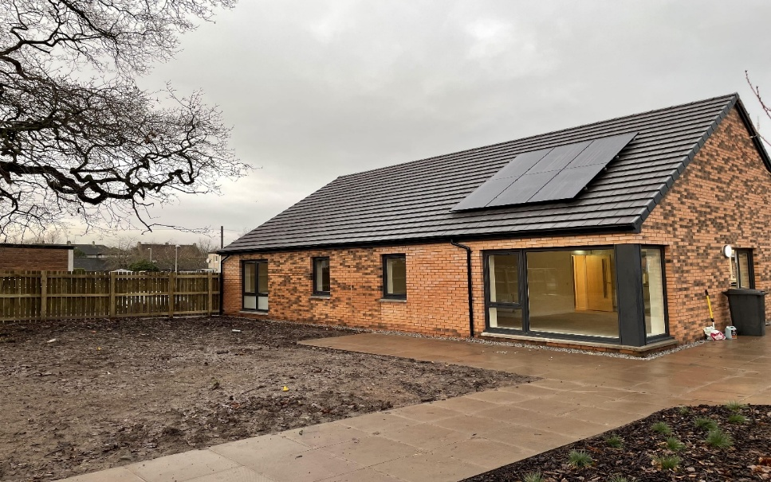 | 