LOIP 2024/25 – Place based Indicators
Section 1
THEME – WHERE WE LIVE (PLACE)
LOIP Outcome 9 – Capitalise on opportunities to collaborate digitally and eliminate digital exclusion
Key Performance Measure | 2019/20 | 2020/21 | 2021/22 | 2022/23 | 2023/24 | Progress | Trend Status
Full fibre coverage of premises (%) | 4  (8) | 6  (16) | 8  (26) | 19  (39) | 26  (52) | Whilst its is an improving picture the trend is significantly lower than the national average.
>=30Mbit/s coverage of premises (%) | 84  (92) | 85  (93) | 85  (93) | 88  (94) | 90  (95) | Trend dhows an improving picture over the 5 year period.
Premises unable to access 10Mbs broadband (%) | 9  (3) | 8  (3) | 9  (3) | 6  (3) | 5  (3) | Trend shows an improving picture over the 5 year period.
LOIP Outcome 10 – Improve transport connectivity across our region to increase opportunities to access employment, education and leisure, particularly in our most rural areas
Key Performance Measure | 2019/20 | 2020/21 | 2021/22 | 2022/23 | 2023/24 | Progress | Trend Status
SIMD Access (Percentage of people living in 15% ‘most access’ deprived areas) | 32.6  (15.8) | 32.7  (16.2) | 32.6  (16.4) |  |  | The % of people living in access deprived SIMD areas has remained at a similar level over the 3 year period, however is nearly double the national average
LOIP Outcome 11 – Work with our communities to help reduce Carbon Emissions and positively combat Climate Change through education, behavioural change and supporting initiatives which will make a positive difference
Key Performance Measure | 2019/20 | 2020/21 | 2021/22 | 2022/23 | 2023/24 | Progress | Trend Status
Carbon Emissions (Carbon dioxide (CO2) emissions per capita) | 6.63  (4.66) | 5.99  (4.12) | 6.84  (4.56) | 5.7  (4.3) |  | The five year trend shows an improving picture.
Percentage of household waste recycled | 29.52  (44.85) | 30.10  (42.01) | 39.83  (43.00) | 45.05  (43.34) | 41.2  (43.5) | The five year trend shows an improving picture.
LOIP Outcome 12 – Develop high quality , affordable homes to help meet identified demand and improve the quality of lives of our communities
Key Performance Measure | 2019/20 | 2020/21 | 2021/22 | 2022/23 | 2023/24 | Progress | Trend Status
Crime Rate (per 10,000 working age population)  Source: Scottish Government Recorded Crimes in Scotland | 570  (564) | 555  (554) | 588  (529) | 530  (531) | 541  (546) | The 5-year trend has shown an improvement, with the last 2 years being below the national average
Dwelling Fires (Number of dwelling fires per 100,000 population)  Source: Community Planning Outcome Profiles | 65.83  (89.50) | 49.90  (85.29) | 61.83  (84.52) | 60.4  (79.02)
Percentage of dwellings with an Environmental Performance Certificate band C or above  Source: Scottish Government: Domestic Energy Performance Certificates | 40  (60.75) | 33.82  (63.07) | 39.07  (64.8) | 34.65  (66.53) | 49.03  (64.56) | The five year trend has shown an overall improvement but still well below the national average.
Common Assault (per 10,000 population)  Source: Scottish Government Recorded Crimes in Scotland | 119  (107) | 104  (96) | 123  (108) | 104  (106) | 120  (108) | There have been fluctuations across the 5 year reporting period with Dumfries and Galloway sitting above the national average
Breach of the peace (Crude rate per 10,000 population) N.B. now classed under “Threatening /Abusive Behaviour”  Source: Scottish Government Recorded Crimes in Scotland | 124  (91) | 117  (90) | 136  (88) | 121  (80) | 114  (78) | Whilst the D&G trend has continued to decrease over the last 3 years, the current figures are sitting above the national average.
Road traffic accident casualties (Age-sex standardised rate per 100,000)*  Source: Scottish Public Health Observatory (ScotPHO) |  | 69.2  (54.7) |  | 69.8  (51)

Section 2

Examples of Place based stats used for Kirkconnel/Kelloholm Locality Plan
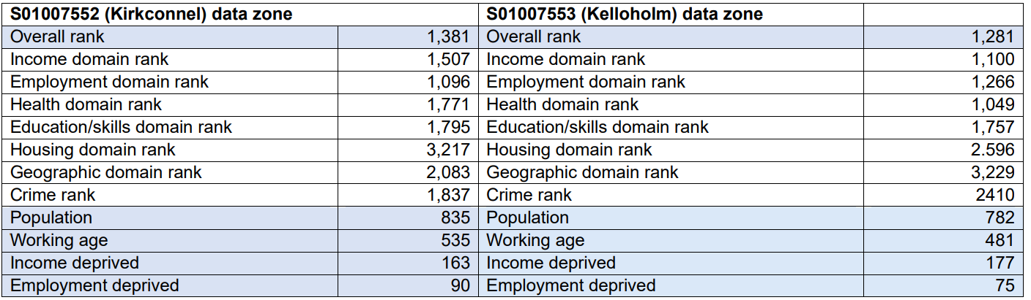
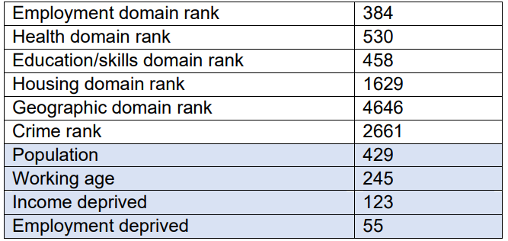
Education Locality based stats  - Attendance  - Attainment  - Participation measure  - School leaver information/positive destinations | Work and Economy  - No. of private businesses  - Labour market participation  - Employment-population ratio  - Employment/unemployment rate  - Workplace based employment  - Claimant count unemployed | Housing  - % social housing

Section 3
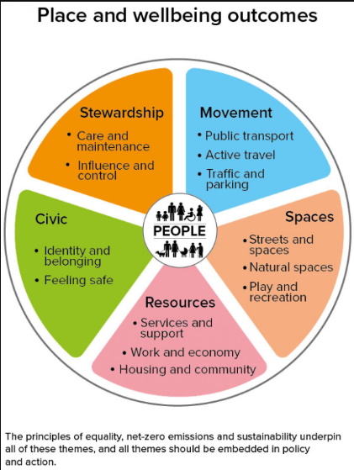

Statistics from measuring impact of Council Plan which contribute to Place and Wellbeing Outcomes(above)
Stewardship | Movement | Spaces | Resources |  |  | Civic
CO2 emissions area per capita | Main mode of travel - Walking | Street Cleanliness score | Proportion of properties receiving Superfast Broadband | Value of Inward Investment opportunities secured | Number of days to process Council Tax Reduction (new claims) | Number of farms checked to ensure legal compliance in their trading activities
Number of adults and young people taking part in influence and engagement activity through CLD – (including community planning / participatory budgeting / local and national consultations / coproduction and influencing service design | Main mode of travel - Bicycle | Proportion of adults satisfied with street cleaning | Percentage of Premises able to access Superfast Fibre Broadband | Value of investment in Net Zero opportunities | Homeless households who have been permanently rehoused as a percentage of all social rented lets | The percentage of failed water samples followed up
Percentage of adults supported at home who agree that they had a say in how their help, care or support was provided | Main mode of travel – bus | Proportion of total household waste arising that is recycled | Percentage of NEC new, renewal and replacement applications made online via GetyourNEC.scot | Value of investment in Natural Capital opportunities | Number of successful interventions on tenancy evictions which prevent homelessness
Percentage of adults supported at home who agree that their services and support had an impact in improving or maintaining their quality of life | Frequency of walking in previous 7 days | Percentage of adults satisfied with refuse collection | Percentage of new library members who apply online | Investment in Economic Development and Tourism per 1,000 population | Value of additional benefits identified through Financial Inclusion Advice income maximisation services which will focus on pension age benefits only
Percentage of adults supported at home who agree that they are supported to live as independently as possible | Adults (16+) – who used a local bus service in the past month agreed buses are environmentally friendly | Proportion of adults satisfied with parks and open spaces | Percentage of library resources borrowed online | Immediate available employment land as a % of total land allocated for employment purposes | Percentage of Community Care Grant Decisions within 15 days
 | Adults (16+) – who used a local bus service in the past month agreed finding out about routes and times is easy | Percentage of A class roads considered for maintenance treatment | Total subscriber profiles on GovDelivery | Proportion of increase in client turnover from community, green and inclusive enterprises | Number of days to process Council Tax Reduction (new claims)
 | Adults (16+) – who used local bus services in previous month 2 or 3 times a week | Percentage of B class roads considered for maintenance treatment | Proportion of adults satisfied with local schools | Private Sector Business Sites | Number of days to process Housing Benefit (New Claims)
 | Customer satisfaction with pavements and footpaths | Percentage of C class roads considered for maintenance treatment | Proportion of pupils entering positive destinations | Number of business gateway start-ups per 10,000 population | Number of participants on sessions for those with a disability/additional support needs
 | Customer satisfaction with respect to the condition of cycle routes/lanes | Percentage of unclassified roads considered for maintenance treatment | Participation rate for 16-19 year olds | Percentage of young people who start-up businesses | Number of adult participants referred to council physical activity sessions through social prescribing by NHS Partners
 | Adults’ views on satisfaction with public transport in the previous month | Customer satisfaction safety on the roads | Modern Apprenticeship achievements as a percentage of all leavers in Dumfries and Galloway | Percentage of new business starts with female ownership | Number of participants attending Community based physical activity opportunities for adults
 |  | Customer satisfaction street lighting | Number of non school facilities providing adult learning | Quarterly business creations and closures per 10,000 adults | Number of children and young people with improved mental health and wellbeing outcomes through Community Learning and Development activity
 |  | Customer satisfaction with respect to the condition of road surfaces | Number of online digital classes per year for adult learners | Business Survival Rate (3 Year) | Number of adults with improved mental health and wellbeing outcomes through Community Learning and Development activity
 |  |  | Number of adults engaged in lifelong learning activity | Proportion of people earning less than the living wage | Number of jobs supported (created, safeguarded or transitioned)
 |  |  | Number of adults engaged in Community Learning and Development activity | Percentage of unemployed people assisted to work from Council programmes | Number of Planned Jobs from completed inward investment projects
 |  |  | Number of adults completing a nationally accredited award | Claimant count as a percentage of working age population | Job Postings by Occupation category
 |  |  | Number of adults engaged in family learning through Community Learning and Development activity | Payrolled Employment | Percentage of young people and adults who report an Improvement in their confidence, skills, individual, family, community or working life following participation in lifelong learning activities
 |  |  | Number of adults and young people reached and engaged with through one off promotional events / drop-ins / community events / engagements / etc | Residence-based Employment by Industry sector
 |  |  | Number of children, young person and adults supported to improve their life chances through participation in lifelong learning | Residence-based Employment by Occupation  Job Postings by Industry Sector

